Proposal of Research
Fingerprinting Star Formation: Bridging the Gap in Galaxy Evolution

- Introduction (Statement of Problem)
One of the greatest questions being asked by modern astronomy is how and when galaxies obtained the morphologies that Edwin Hubble classified in a “tuning fork diagram” (Fig. 1) in 1926. Edwin Hubble thought that his diagram represented an evolutionary sequence with four main types: elliptical, spiral, barred spiral, and irregular. Since then engineering and technological advances have opened the door to a much deeper view of the universe, showing that not all galaxies fit in the standard “tuning fork”. For example, many galaxies are interacting, live in groups and clusters, have tidal tails and extended halos.

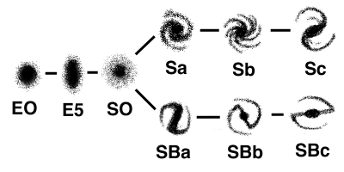
Figure 1-Edwin Hubble’s “Tuning Fork” Diagram

The deep universe contains galaxies believed to be the progenitors of Hubble types, existing beyond the original Hubble sequence. Unfortunately, we cannot directly see how galaxies assemble, grow, and age. We can only see snapshots of the universe and try to solve the puzzle by connecting the distant with the local universe with as many deep snapshots/images as possible. In the past decade, many studies have used deep images taken with the Keck 10-m telescope and Hubble Space Telescope (HST) to search for distant galaxies, in particular, galaxies forming stars 11 billion years ago (z>2). Based on those data, and in more nearby data, astronomers have calculated the cosmic star formation history of the universe and plotted it in a diagram shown in Fig. 2 (Wadadekar, et. al. 2006). Several studies have provided observational evidence that at redshift z~1 (when the universe was ~8 billion years old) there is a sudden decline in the star formation rate (SFR) density in comparison with the early universe. However, the process and mechanisms which have produced the decline of SFR density is still an open question. Therefore, studies of galaxies at intermediate redshifts (0.4< z <1.4) will provide the missing link between the early and today’s local universe. This range is marked the thick line in Fig. 2, with a yellow dot indicating the redshift at which the Sun was born. This is the redshift range that I will be targeting in this project.

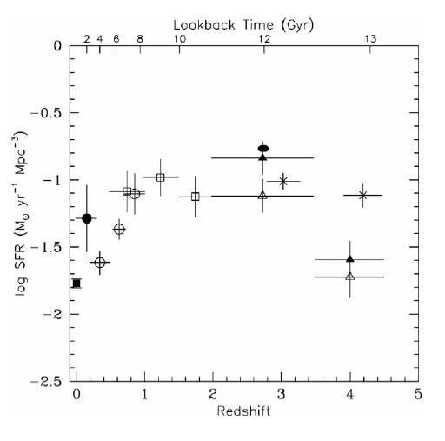
Figure 2 – SFR density (Solar Masses per Year per Megaparsec³) vs. Redshift (Wadadekar, et. al. 2006)

II. Rest Frame Morphologies (Hypothesis)
Star forming regions are dominated by the UV light from short lived, massive, O and B stars, and therefore this area of the spectrum fingerprints such activity. Since spectral colors are band-shifted towards the red when observing objects at z>0, the rest-frame UV spectrum is shifted into the U-bandpass for intermediate-z galaxies. This creates a necessity for U-band observations when analyzing star-forming galaxies at intermediate redshifts.
However, there is a large contrast between the rest-frame UV morphologies of galaxies and their rest-frame optical morphologies (de Mello, et. al. 2006, Teplitz, et. al. 2006). In many cases rest-frame UV morphologies can appear to be clumpy and irregular, while their rest-frame optical (B-,V-, and i-bands) morphologies reveal nicely formed Hubble type objects (Figure 3). This occurs because the optical detects older stellar populations that are no longer forming young stars, as well as the gas and dust structure of these galaxies. Therefore, a multiwavelength view is essential to the understanding of what morphologies harbor star formation and is the focus of this project.
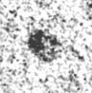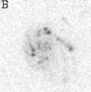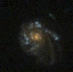
U-band B-band BVI
Figure 3 – Multiwavelength imaging of a spiral galaxy at z=0.7 (Voyer, et. al. 2008)

Recently, I started working on a preliminary study detecting UV bright galaxies in the first space-based U-band observations of the Hubble Ultra Deep Field (UDF) taken with Hubble’s WFPC2/F300W camera. I have created a catalog of 95 U-band galaxy detections and matched them with the GOODS B-band based catalog (Giavalisco et. al. 2004) created from images taken with Hubble’s ACS camera during the GOODS survey of the Chandra Deep Field South. I have also been collaborating with Harry Teplitz and Brian Siana from Caltech to include far-UV photometry and images of these galaxies taken with Hubble’s ACS-Solar Blind Channel MAMA detector in the catalog. This multiwavelength view of these objects provides an excellent platform for the evaluation of their contribution to the SFR density at intermediate redshifts. However, this current sample is statistically too small, therefore, I propose to increase the sample in order to establish the morphology of star forming objects during this epoch. This data will also provide further evidence in pinpointing when Hubble types emerged in the evolutionary timeline.

III. Method
1. Increase sample by adding Hubble Space Telescope (HST) archival U-band images
Continuing from my preliminary work, I will be using U-band observations to detect star forming galaxies at intermediate redshifts. I will retrieve archival HST U-band data from the Hubble Deep Fields, GOODS parallels, and UDF parallel fields. I will also retrieve any optical band images of these fields to achieve a multiwavelength coverage of the morphologies of the UV galaxies. Using the code SourceExtractor (SE) (Bertin & Arnouts 1996) on these images I will create multiple catalogs of galaxies and their photometry.
This method of approach to studying star formation is important to the uniformity of the study. Most of the research looking at the early universe has been conducted through UV imaging and analysis, while studies of the local universe have been conducted through this and other methods, such as looking at Hα. By using UV emission to detect star formation at this intermediate epoch of galaxy assembly, there will be more consistency in the method of study over the entire redshift range.
2. Obtain new UV imaging of galaxies to improve the statistics of the sample
New U-band images will be obtained with the Wide Field Camera 3 (WFC3) that will be installed on HST during the next service mission scheduled for August 2008. The main focus of WFC3’s science program, “Star Formation, Near and Far”, parallels the overall goals of my research. WFC3 will initially be used to probe both nearby and intermediate redshift ranges in the GOODS-south field in multiwavelength (UV-NIR, 9,000 Å -17,000 Å) bands. The high spatial resolution and extreme sensitivity of the camera will produce highly resolved imaging of a large sample of star forming galaxies from which morphologies, stellar masses, and luminosities can be accurately analyzed. WFC3 will also do spectroscopy on sources with its low-resolution spectroscopic prisms (grisms). This will provide very accurate spectroscopic redshifts for this sample of galaxies in place of less accurate photometric redshifts that are estimated from galaxies broadband colors. Knowing precise redshift information is important in placing morphologies and SFR accurately on a timeline. All of these data will be available immediately to the astronomical community for use, and I will access the data as soon as possible.
3. Catalog U-band detections and create a multiwavelength survey of observations
Using SE on WFC3 data I will produce multiple catalogs of galaxies and their photometry. The optical catalogs will be matched to the U-band to select out only star forming objects from the sample. I will create cutout images of each galaxy in the multiple broadbands to be placed side-by side for morphological analysis. To confirm that these objects are from the intermediate epoch I will compare the sample with my preliminary U-band catalog to see how many sources are the same. I will also match this catalog to previous GOODS-S catalogs to obtain redshifts and spectral types of these objects, and check the accuracy of my photometry.
4. Analyze redshifts, spectral types, and morphology of star forming galaxies
It is important to establish how the distribution of galaxies correlates with redshift, spectral types, and U-band magnitude. Plotting the redshift distribution of the sample of UV selected galaxies will gauge their star formation activity as a function of time. This will provide evidence towards possible shut-downs in star formation activity at a certain points in the intermediate redshift epoch. Mapping out the spectral type distribution of the sample will reveal what types of galaxies populated the star forming regime. We want to know how the spectral energy distributions of the sample correlate with the morphological parameters (Lotz, et. al. 2006). Because it is suspected that the global SFR begins to decrease during this epoch, it is also important to look at the redshift and spectral type distributions in comparison to the distributions in other bandpasses.
5. Measuring colors, star formation rates, and redshifts of galaxy sample
In order to understand the ratio of old and new stellar populations in the UV bright galaxy sample, I will measure the internal colors, and color dispersions of these sources. I will measure U-B, B-V, and V-I colors, and will mirror the k-correction method of Papovich, et. al. (2003) to analyze the distributions. I will measure the SFR of the overall sample with redshift to better understand the decline in star formation during this epoch. Finally, I will calculate broadband photometric redshifts using as many bandpasses as available in order to reduce error. The photometric redshift will then be compared to all the available spectroscopic redshifts for these objects to test the accuracy of the calculations.
6. Compare UV selected galaxy sample to non-UV selected sample
Many of the galaxies detected in the archival and WFC3 observations will not be highly star forming objects, and contain mixed or older stellar populations. These are non-UV selected objects. By comparing non-UV objects to star forming, UV galaxies, I hope to reveal any trends in spectral types, morphologies, environments, and other physical properties of UV sources. Do star forming galaxies at intermediate redshifts tend to be more irregular than the global population, or do the majority of them have spiral morphologies? Do they participate in many interactions at this point in time? This comparative analysis will unlock many key questions such as these. My comparison sample will be selected from large HDFs such as GOODS and COSMOS.
IV. Predicted Outcomes
The projected outcomes of my project are well aligned with the NASA Science Mission Directorate goals to “measure the luminosities, forms, and environment of galaxies back to the epoch of their formation”, and to generally, “study the evolution of stars and galaxies”. Specifically, my research parallels the research interests of the Observational Cosmology Laboratory at GSFC to better understand “when the first stars and galaxies appeared and their evolution with Cosmic Time”. My work will demonstrate the importance of collaboration and teamwork between scientists in order compile the multiwavelength data necessary for a thorough analysis of the UV bright galaxy sample.
I will produce a complete analysis of redshift distribution, spectral type distribution, and magnitude distribution of a large catalog of intermediate redshift UV bright galaxies. The U-band distributions will be compared against the optical galaxy distributions of the field, revealing how star forming galaxies fit into the global galaxy population at intermediate redshifts. I will also compute measurements of colors and star formations rates for these sources in order to better understand how star formation is evolving during this period of galaxy assembly, and specifically if there is a time of star formation shut-down that correlates with morphological types. My analysis will better pinpoint the redshift at which galaxies evolve into Hubble types. This work will also reveal more about star formation rates during z=0.5 when the Sun was born proving that this broader study is also significant towards understanding the evolution and origins of the local solar system. I will be working together with other individual research scientists and groups both at GSFC and other institutions and organizations to achieve these outcomes.

V. Proposed Timeline
VI. Conclusions
The ultimate goals for this proposal of research are as follows:
- Investigate star formation and galaxy evolution at intermediate redshifts to bridge the gap in our understanding of the early and local universe.
- Analyze the U-band sample to determine possible progenitors for well formed Hubble type objects observed in the local universe.
- Achieve a better understanding as to when Hubble type objects begin to appear in cosmological time.
- Measure the SFR density at the intermediate redshift epoch of the universe.
- Look at star formation rates specifically in z=0.5 galaxies to understand morphologies of galaxies when the Sun was born.

VII. References
Bertin, E. & Arnouts, S. 1996, A&AS, 117, 393
de Mello, D.F., et. al. 2006, AJ, 131, 216
Giavalisco, et. al. 2004, ApJ, 600, L93
Lotz, et. al. 2006, ApJ, 636, 592
Papovich, C., et. al. 2003, AJ, 598, 827
Teplitz, H.I., et. al. 2006, AJ, 132, 853
Voyer, E.N., et. al. 2008, AJ, in preparation
Wadadekar, Casertano & de Mello. 2006, AJ, 136, 1023

Great Observatories Origins Deep Survey
Ultra Deep Field

